La Cuisine du Monde Francophone
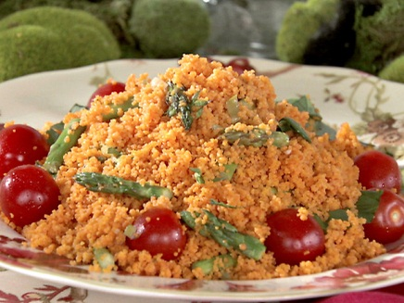
For this project, you and a partner will be making a dish from somewhere in the French-speaking world. Because this unit focuses not only on food, but also on food preparation, you’ll also be expected to explain the ingredients and mode of preparation in French to the rest of the class. You’re going to have to be very specific! We need to be able to leave class and recreate the dish.
Think about the following questions:
How much of each ingredient is present in the dish? How long did you need to cook/bake/cool your dish? How should the dish be served- hot or cold? Is the dish an appetizer, main dish, dessert?
This is also a cultural activity, so be able to explain where the dish comes from, who eats it, and when? Is it a special occasion dish or something most people often eat.
Rubric
Criteria | Excellent! 10-8pts | Pas Mal 7-5pts | Pas d’Effort 4-0pts
Presentation and Taste of Dish | Looks delicious and tastes good! | Looks pretty good; tastes a little strange.  A little disorderly or sloppy. | Looks edible. Very sloppy. Little to no flavor.
Explanation of Ingredients | Both partners speak.  No English is used.  Amounts are given. | One partner speaks.  Little English is used.  Most amounts are given. | One partner speaks a little. English used 3+ times. No amounts given.
Mode of Preparation | Both partners speak.  No English is used.  Instructions are easily understood and recreatable. | One partner speaks.  Little English is used.  Instructions are a little confusing, but mostly OK. | One partner speaks a little. English used 3+ times. No preparation instruction given.
Total points |  |  | /30

